**WEEK 5**

**E-COMMERCE WEBSITE - OUTPUT**

**🏠 Home Page**

The home page provides an **interactive interface** where users can browse and search for products. A **navigation bar** ensures seamless access to the **Home** and **Cart** pages.

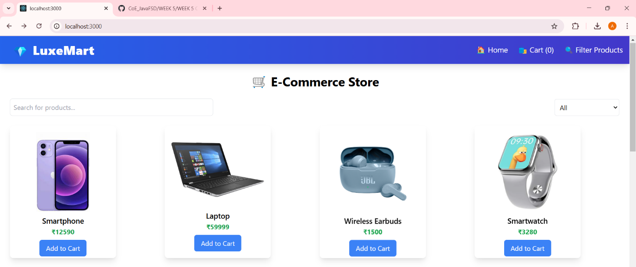

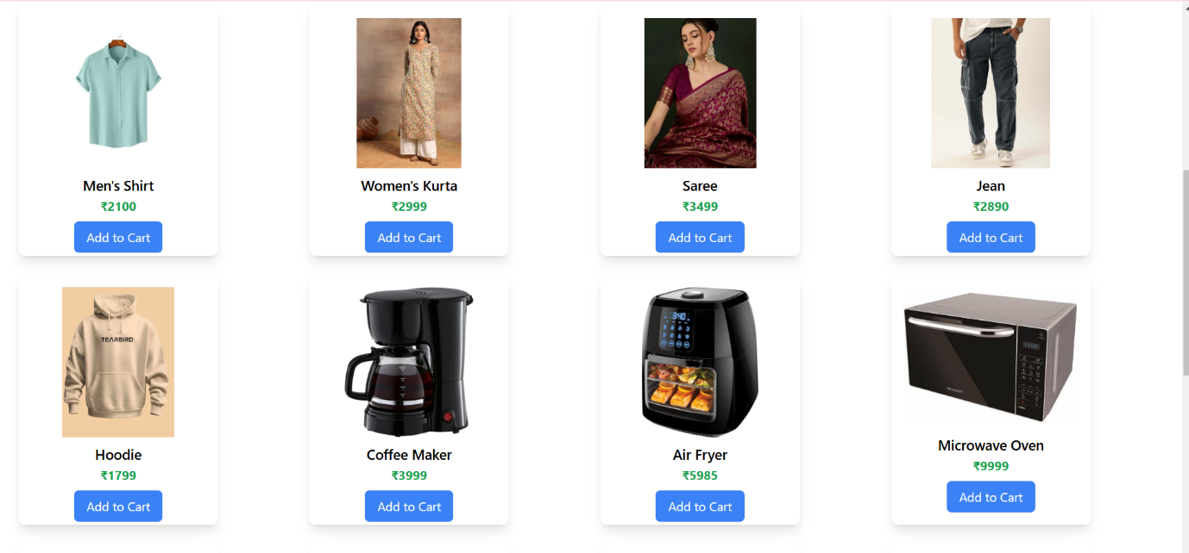

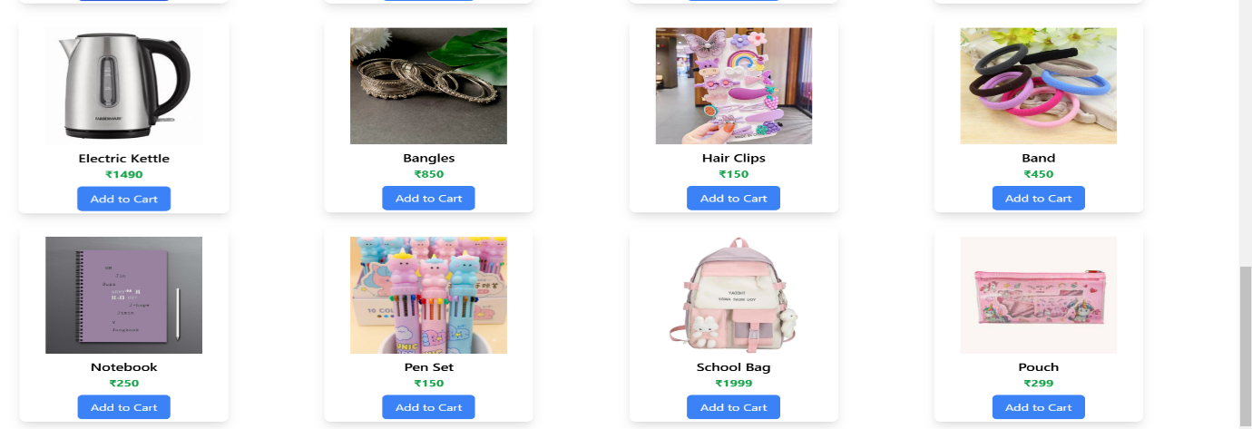

**Product Search**

The website offers an **efficient product search feature**, allowing users to **quickly find items** in two ways:  
  
**1.Manual Search**

A search bar enables users to **enter product names** for instant results.

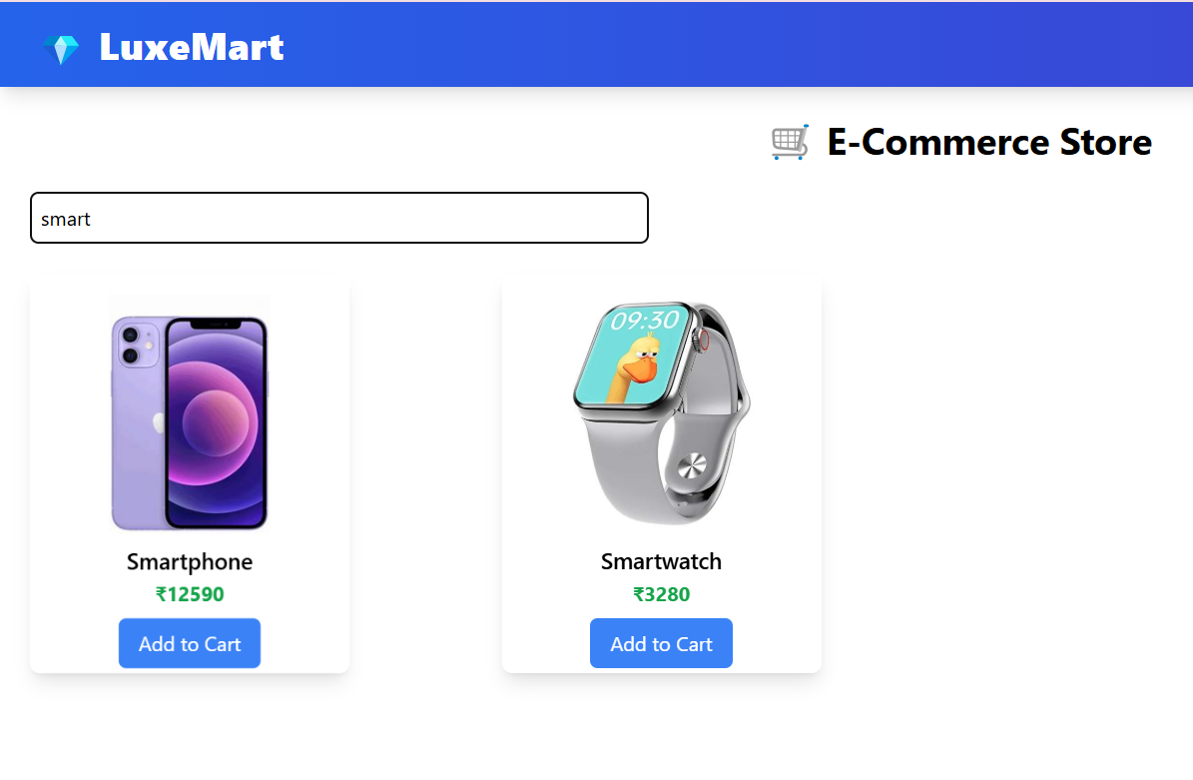

2. **Category Filtering**

Users can refine their search by selecting specific product categories.

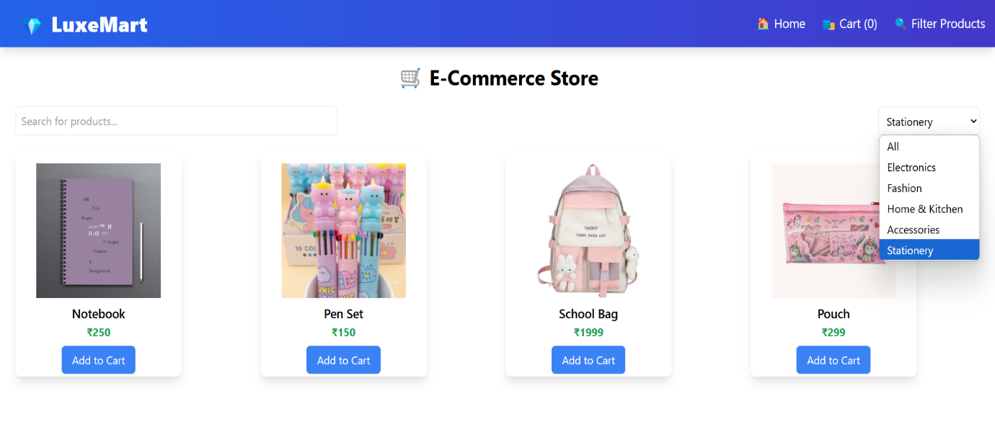

**🏠 Home & 🛍 Cart Icons Functionality**

* **Home Icon**  → Navigates to the **Home Page** for browsing products.

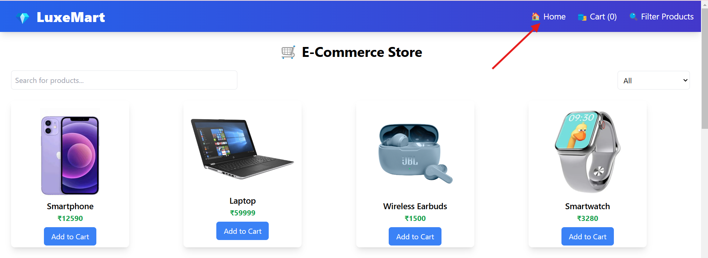

* **Cart Icon**  → Redirects to the **Cart Page**, where users can view selected items.

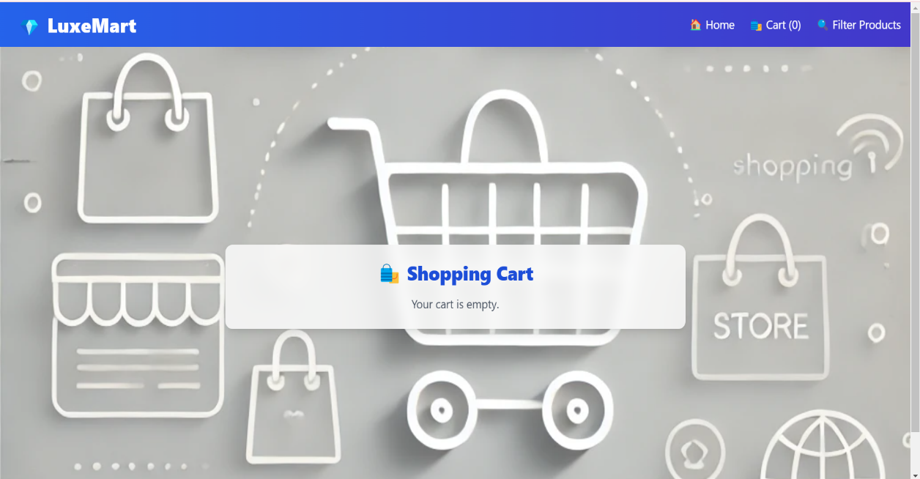

**Cart Count** → Displays the **number of items in the cart**, updating dynamically as products are added or removed.

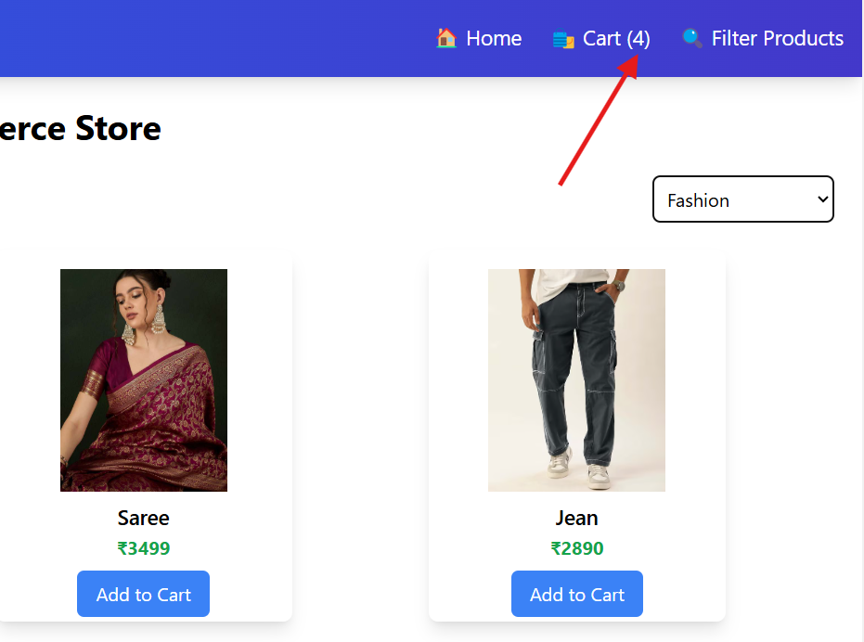

**🛍 Cart Page - Managing Items**

* **📋 Viewing Cart** – Displays **selected products** with their prices and the **total amount** at the bottom.

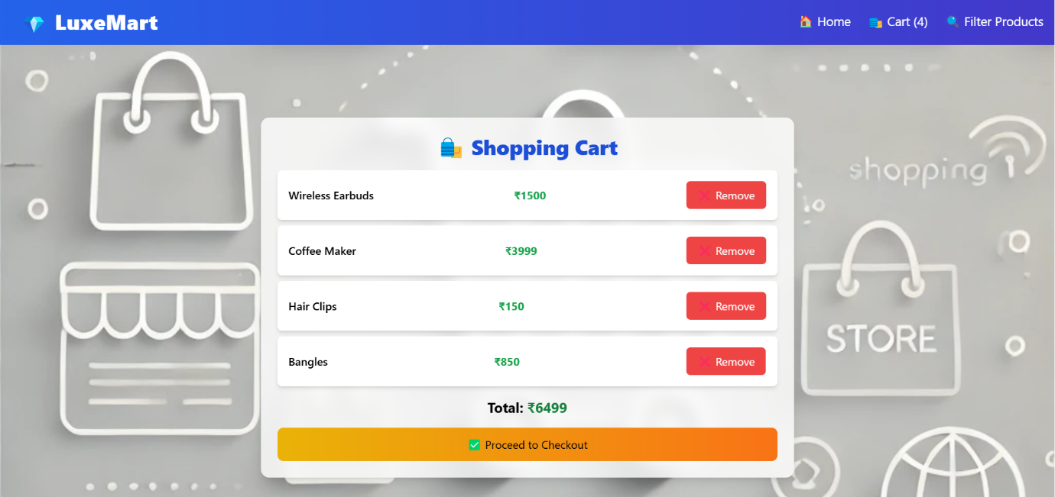

* **❌ Removing Items** – Users can remove individual products.

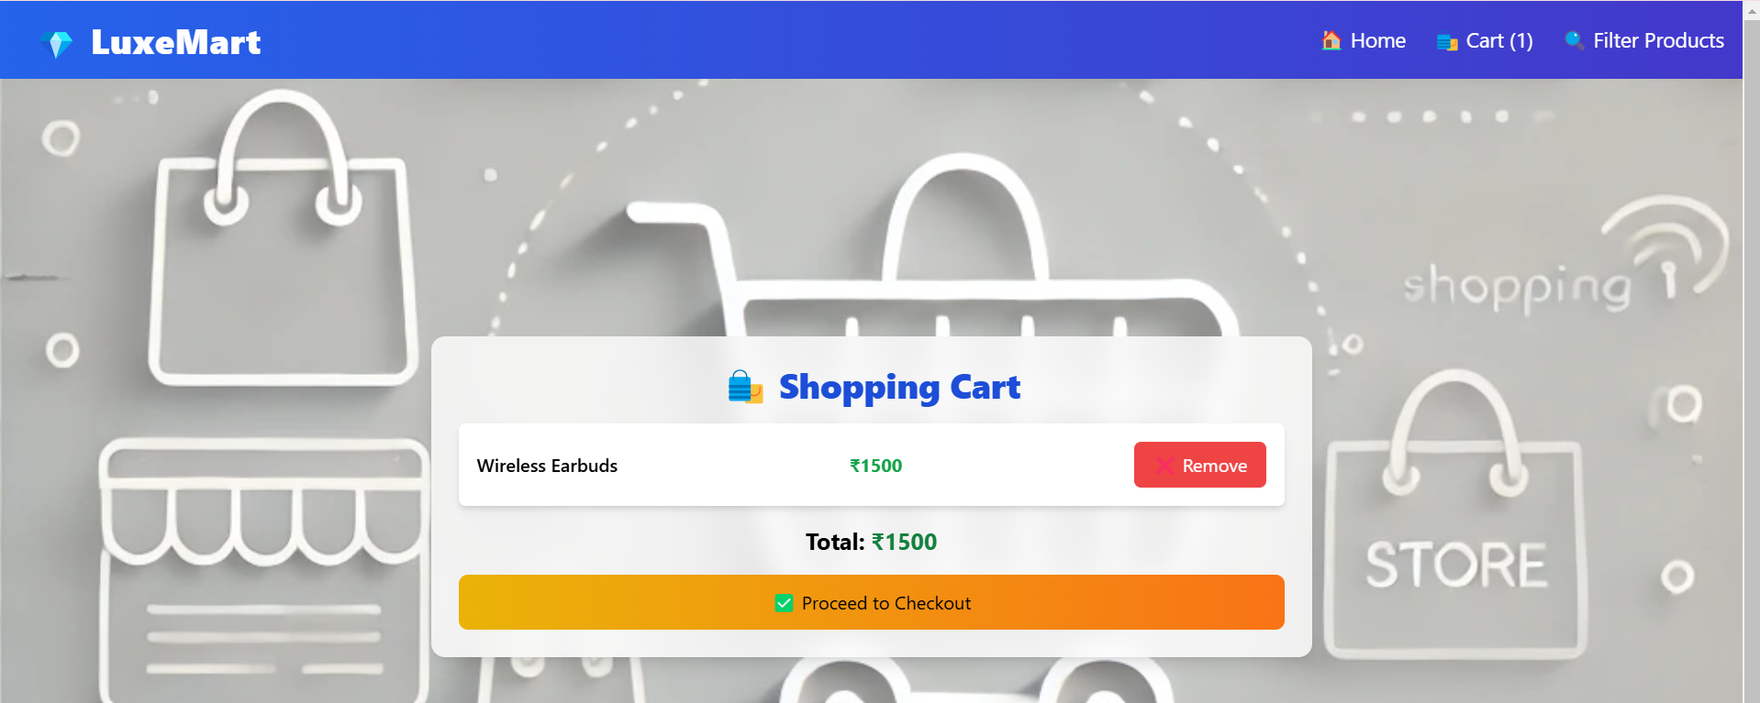

Clearing all products from cart

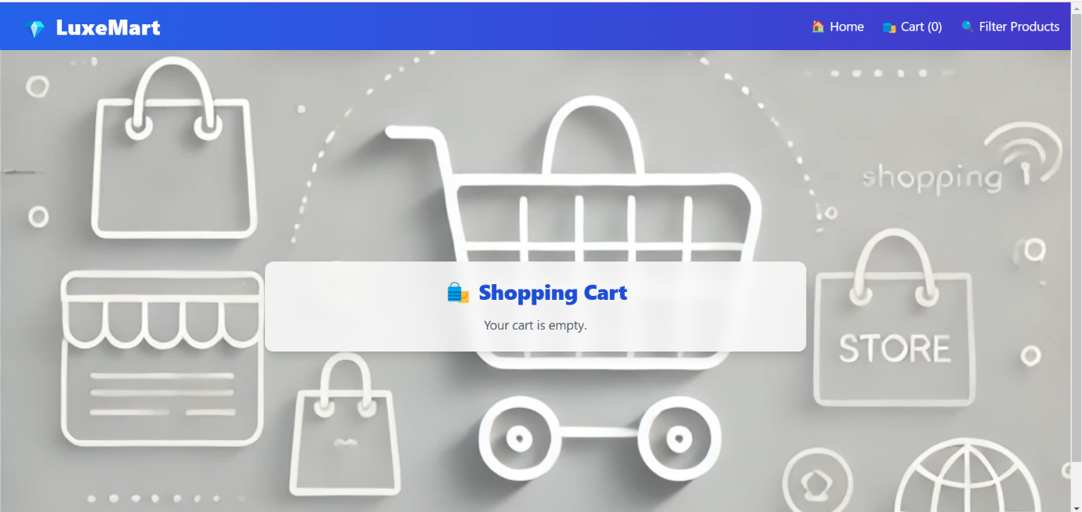

**This e-commerce website leverages React, React Router, Context API, and Tailwind CSS to create an engaging and smooth shopping experience, with a clean, intuitive, and responsive UI design.**